Lesson 5 Quiz

**4/5** points earned (80%)

Correct

1 / 1 points

1. Given a sequence database, as shown in Table 3, with support threshold minsup = 3, which of the following sequences are frequent?

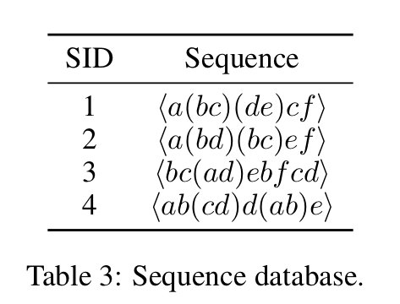

< abc >

< a(bc) >

< ade >

< acf >

None of the above

Correct

1 / 1 points

2. Suppose we use Generalized Sequential Patterns (GSP) to find the frequent sequential patterns. After scanning the database once, we find the frequent singleton sequences are: a, b, d. Which of the following could be possible length-2 candidate sequences?

<(ac)>

<ab>

<ad>

<(bd)>

Correct

1 / 1 points

3. Given a sequence database, as shown in the following table, suppose we use the SPADE algorithm to find the frequent sequential patterns. Which of the following sequences (in the format of <SID, EID>) belong to the mapped database of item b?



<3, 1>

<3, 2>

<4, 1>

<1, 2>

1  
point

4. Given a sequence database, as shown in Table 10. Suppose min_sup = 1. Which of the following does not belong to the < a >-projected database?

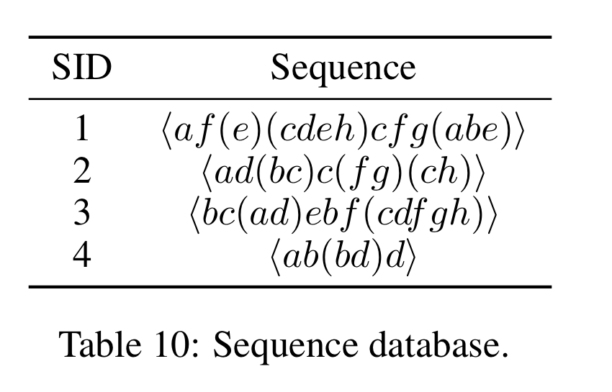

< f(e)(cdeh)cfg(abe) >

< d(bc)c(fg)(ch) >

< (_d)ebf(cdfgh) >

< b(bd) >

All of the above belong to <a>-projected database.

1  
point

5. Suppose we use the CloSpan algorithm to find all closed sequential patterns from a sequence database with minimum support 15. During the mining process, we derive the following sequences along with the sizes of their projected DBs: <c>: 50, <ac> 45, <b> 30, <bc>: 30. Then we use the backward sub-pattern rule and the backward super-pattern rule to prune redundant search space. Which of the projected DBs will remain after the pruning?

<c>

<bc>

<b>

<ac>

Correct

1 / 1 points

6. Given a sequence database, as shown in Table 2, with support threshold minsup = 3, which of the following sequences are frequent?

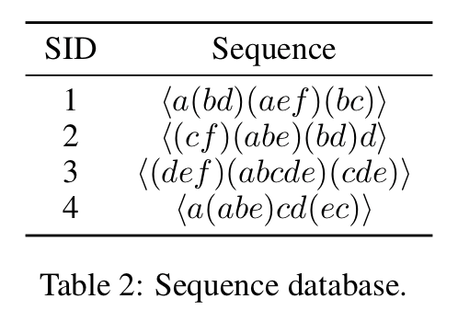

< abc >

< f(ab) >

< (bd)b >

< (ae)c >

None of the above

Correct

1 / 1 points

7. Given a sequence database as shown in the following table, suppose we use the SPADE algorithm to find the frequent sequential patterns. Which of the following sequences (in the format of <SID, EID>) belong to the mapped database of item a?



<4, 1>

<3, 2>

<1, 2>

<1, 1>

1  
point

8. Given a sequence database, as shown in Table 10. Suppose min_sup = 1. Which of the following does not belong to the < a >-projected database?



< f(e)(cdeh)cfg(abe) >

< d(bc)c(fg)(ch) >

< (_d)ebf(cdfgh) >

< b(bd) >

All of the above belong to <a>-projected database.

1  
point

9. Suppose we use the CloSpan algorithm to find all closed sequential patterns from a sequence database with minimum support 15. During the mining process, we derive the following sequences along with the sizes of their projected DBs: <c>: 50, <ac> 40, <ab> 30, <bc>: 50. Then we use the backward sub-pattern rule and the backward super-pattern rule to prune redundant search space. Which of the projected DBs will remain after the pruning?

<ab>

<c>

<ac>

<bc>

Correct

1 / 1 points

10. Given a sequence database, as shown in Table 11. Suppose min_sup = 1. Which of the following does not belong to the < d >-projected database?

< (bc)c(fg)(ch) >

< ebf(cdfgh) >

< (c_eh)cfg(abe) >

< de >

11. Suppose we use the CloSpan algorithm to find all closed sequential patterns from a sequence database with minimum support 15. During the mining process, we derive the following sequences along with the sizes of their projected DBs: <c>: 50, <ac> 50, <ab> 30, <bc>: 30. Then we use the backward sub-pattern rule and the backward super-pattern rule to prune redundant search space. Which of the projected DBs will remain after the pruning?

<ab>

<bc>

<c>

<ac>

Correct

1 / 1 points

12. Given a sequence database as shown in Table 1 with support threshold mini-support (minsup) = 3, which of the following sequences is frequent?

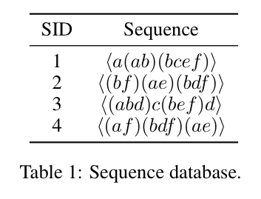

< abc >

< (ab)f >

< f(bd) >

< a (bf) >

13. Suppose we use Generalized Sequential Patterns (GSP) to find the frequent sequential patterns. After scanning the database once, we find the frequent singleton sequences are: a, b, d. Which of the following could be possible length-2 candidate sequences?

<(bc)>

<(bd)>

<ac>

<ab>

Correct

1 / 1 points

14. Given a sequence database, as shown in Table 12. Suppose min_sup = 1. Which of the following does not belong to the < e >-projected database?

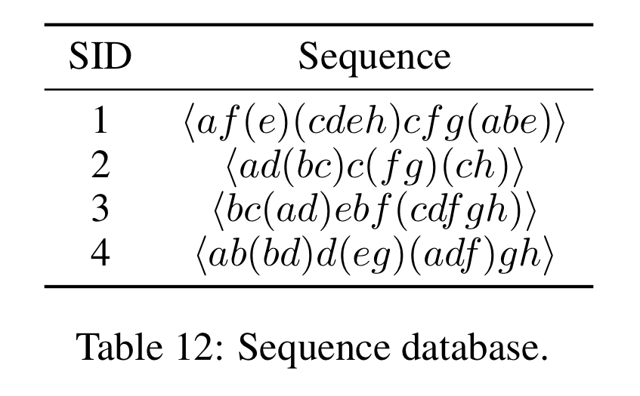

< (_g)(adf)gh >

< bf(cdfgh) >

< (cdeh)cfg(abe) >

< (_h)cfg(abe) >

Correct

1 / 1 points

14. Given a sequence database, as shown in the following table, suppose we use the SPADE algorithm to find the frequent sequential patterns. Which of the following sequences (in the format of <SID, EID>) belong to the mapped database of item c?



<3, 2>

<1, 1>

<4, 1>

<1, 3>

Correct

1 / 1 points

15. Given a sequence database, as shown in Table 11. Suppose min_sup = 1. Which of the following does not belong to the < d >-projected database?

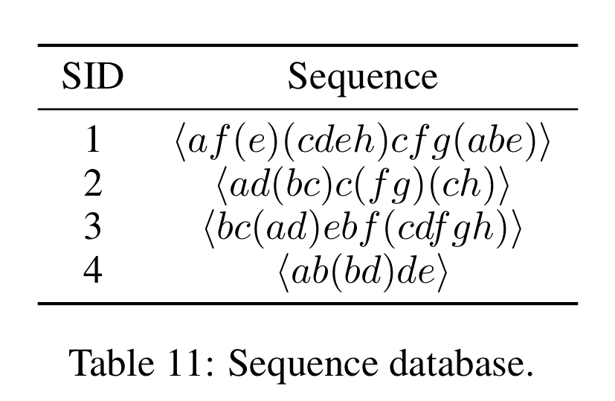

< ebf(cdfgh) >

< (bc)c(fg)(ch) >

< (c_eh)cfg(abe) >

< de >

Submit Quiz